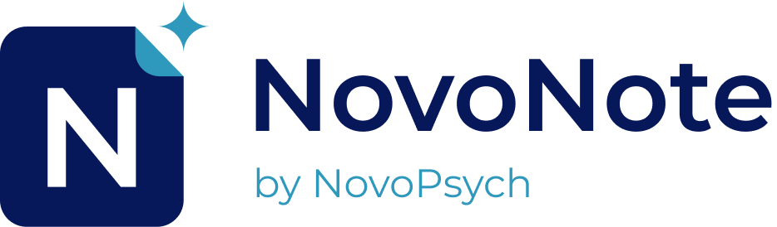

NovoPsych Pty Ltd

NovoPsych.com.au

Phone: 03 7019 4244

Email: info@novopsych.com

**NovoNote  
Note Taker Fact Sheet**

Clinicians at our clinic are using NovoNote, an AI tool designed to assist with taking notes during your session. Below is an explanatory statement about our use of this technology.

**Purpose of the AI note taker**: The use of an automated note taker was adopted to enable us to focus more on communication and patient care during sessions, rather than being distracted by note-taking. By changing the way we take notes, we also aim to provide more accurate and detailed documentation of our sessions.

**Your Consent:** Before using NovoNote, your clinician will ask for your consent. You have the right to withdraw your consent at any time.

**About NovoNote**: NovoNote is produced by the Australian company founded in 2012, NovoPsych. NovoNote is a secure and encrypted platform that converts the audio from our consultations into clinical summaries.

**Compliance and Security**: NovoNote complies with the Australian Privacy Principles and is compliant with AHPRA and HIPAA standards. It adheres to industry encryption and security protocols. Importantly, the audio recordings from sessions are never saved; instead, they are transformed into a transcript of the session and then discarded. NovoNote stores data on a secure server in Australia and our data processors never train AI models using your data.

**What is Saved:** As a healthcare provider, we keep notes of our contact with you to help us serve you better. NovoNote helps by transcribing the session and then providing a summary of that session. Typically, the transcript of the session will be deleted and will not make up part of your patient file, while the summary is saved into our practice management system.

**Questions**: Your clinician may be using this note-taking system during your sessions. Please do not hesitate to ask if you have any questions or concerns about this process. For further information on NovoNote’s security measures and protocols, please see their security page: [NovoPsych.com.au/NovoNote-Security](http://novopsych.com.au/novonote_security)

We are committed to providing you with the highest standard of care through these advanced technological practices.

Contact NovoNote

[NovoNote@NovoPsych.com](mailto:NovoNote@NovoPsych.com)

[NovoPsych.com.au/NovoNote](https://novopsych.com.au/NovoNote)